**A TECHNICAL REPORT ON**

**STUDENT INDUSTRIAL WORK EXPERIENCE SCHEME (SIWES)**

**CARRIED OUT AT**

**KPONKIUS DEV Computer Institute,**

**MUBI, ADAMAWA**

**FROM: 13TH February, 2023**

**TO: 28TH JULY, 2023**

**BY**

**ABATCHA BALA**

**(NOU223154011)**

**SUBMITTED TO THE DEPARTMENT OF COMPUTER SCIENCE,**

**FACULTY OF SCIENCE, NATIONAL OPEN UNIVERSITY OF NIGERIA,**

**GULAK COMMUNITY STUDY CENTRE, IN PARTIAL FULFILLMENT FOR THE AWARD OF BACHELOR OF SCIENCE (BSC) IN COMPUTER SCIENCE**

**AUGUST, 2023**

**DEDICATION**

I dedicate this report to the Almighty God for the guidance and protection accorded me throughout the programme.

# ACKNOWLEDGMENTS

I thank God Almighty for making me to undergo students industrial work experience scheme (SIWES) successfully.

My gratitude goes to my parent for their prayers, financial and moral support during my attachment.

I also appreciate the kind gesture of my brothers and sisters and those who supports me in prayers and contribution during my industrial attachment.

I whole heartedly thank my Head of department, SIWES coordinator and all lectures of Computer Science for their effort to ensure my success as their students.

I am greatly indebted to my co-SIWES students to mention, may God strengthen our relationship together and grant us academic excellence.

I sincerely thank you all for your contribution and support.

**ABSTRACT**

*The report summarises the result of work done during my SIWES experience, the technical report consists of four chapters, which comprises of introduction, history and criteria’s of SIWES in chapter one followed by their aims and objectives, historical background, organizational structure of the organization in chapter two, while chapter three consist of the work actually carried out during the SIWES programme and lastly chapter four consist of the summary, conclusions and recommendation.*

**Table of Contents**

**Title page - - - - - - - - - i**

**Dedication - - - - - - - - - ii**

**ACKNOWLEDGEMENT - - - - - - - - iii**

**Abstract - - - - - - - - - - iv**

**CHAPTER ONE**

1.0 Introduction - - - - - - - - - 1

1.1 Background of SIWES - - - - - - - 1

1.2 Brief History of SIWES - - - - - - - 1

1.3 Aims and Objectives of SIWES - - - - - - 2

**CHAPTER TWO**

2.1 Brief History of the Organization. - - - - - - 3

2.2 The Objective of the Organization. - - - - - - 3

2.3 Organizational Chart - - - - - - - - 4

**CHAPTER THREE**

**EXPERIENCE ACQUIRED**

# 3.1 Introduction HTML - - - - - - - - 5

## 3.2 WHAT IS CSSS - - - - - - - - 11

3.3 Introduction to Bootstrap - - - - - - - 15

3.4 Introduction to JavaScript - - - - - - - 16

**CHAPTER FOUR**

4.1 Summary - - - - - - - - - 16

4.2 Conclusion - - - - - - - - - 16

4.3 Problems - - - - - - - - - 17

4.4 Recommendations - - - - - - - - 18

**CHAPTER ONE**

**1.0 INTRODUCTION**

The concept behind industrial training schemes is to acquire practical, knowledge in addition to what has been learn institution. The four months mandatory supervised industrial attachment is program instituted by the federal government to help student for their different field of studies.

### 1.1 BACKGROUND OF SIWES

It aims at exposing student to the practical and the actualization of work situation which they may meet after graduation and the learning is meanly expected to produce graduate qualification to meet man power of employments of (ITF), there was growing concern amount the industrialist that graduate of higher learning do not passes adequate background student for the opinion that theoretical education going higher institution was responsive enough to meet the need of employers of the labour as a requirement of national board for technical education (NBTE) polytechnic training before obtaining the National Diploma (ND).

Experience scheme (SIWES), is a National programme introduced by Government in 1974 for student in tertiary institution

### 1.2 BRIEF HISTORY OF SIWES

**SIWES** was established by **ITF** in 1973 to solve the problem of lack of adequate practical skills preparatory for employment in industries by Nigerian graduates of tertiary institutions.

The program “Student industrial work experience scheme” is a pure skill-acquisition program structured for the tertiary institutions as a complementary and enhancement program to the theoretical education, laboratory and workshop practices engaged in by student in different higher institutions. The SIWES was initiated to improve the student’s technical abilities (performance/knowledge) and expose them to industrial culture thereby preparing them to be acquainted with the roles to play towards the technological advancement of the nation.

It is there for a practical aspect of the academic works, which the students may not be opportune to carry out throughout their stay in the higher institutions. Based on this fact, the Federal Government decided to establish a body (regulatory) which engages in the training of the technical manpower. The body is named industrial Training Fund (ITF). The government also undertook to make up for the deficiencies by structuring and established Students Industrial Training (SIT) as it was then called but in 1973 the SIWES was formed which is the subsidiary.

### 1.3 AIMS AND OBJECTIVES OF SIWES

1. One of the objectives of SIWES is to create an avenue for students to acquire industrial skills to complement their theoretical knowledge and improve their experiences in their course of study.
2. The program prepares the students for industrial working conditions prior to their graduation.
3. To enable the students to learn personal relationship with employers and co-employees on graduation.
4. It exposes the student to working methods and techniques in handling equipment and machinery.
5. It develops the student in make critical and realistic approaches to solving problem.
6. It serves as a way of improving the abilities of the students and to contribute to the growth of the nation.
7. It gives the students the opportunity to practice what they have been taught in various disciplines.
8. The SIWES program strengthens the employer’s involvement in preparing the students for employment.

# CHAPTER TWO

### 2.1 BRIEF HISTORY OF KPONKIUS DESIGNZ

Kponkius Dev Computer Institute was established in 2013, the Institute is the leading institution that provides computer Education in the Development of Information Technology.

The Institute have graduated about 15,000 students and presently have over 500 registered students. For more than 10 years, the Institute has been a pioneer in the development of Information Technology in the State. With a crop of versatile professionals, cutting-edge course contents, enormous Hardware, Software and Computer facilities to mention just a few of the reasons top companies consistently choose Kponkius Dev students for top jobs and for training programmes.

### 2.2 PHILOSOPHY AND GOALS

Kponkius Dev Computer Institute, echoes the commitment to an open admission philosophy and dedicated to the “hands-on” approach to computer education. Designed to address the educational and employment needs of the country, these goals appear in summary below:

1. To provide a one-year curriculum of programmes leading to a Diploma/Certificate in Computer Science, Engineering (with emphasis on practical) for employment purposes.
2. To provide corporate/short term specialised in depth training by highly skilled professionals at managerial levels in industries and Government parastatals.
3. To provide occupational education and training in Information Technology, business skills and human services at a semi-professional level, to prepare students for career in business, industry and Government Parastatals.
4. To maintain high standards in a wide range of quality programmes designed to meet the needs of variety of students.

**2.3 ORGANIZATION STRUCTURE**

**Managing Director**

**Board**

**of**

**Directors**

**Chief Marketing**

**Officer**

**Admin Manager**

**Head**

**,**

**Risk**

**&**

**Compliance**

**/**

**Process Engineering**

**Marketing**

**(**

**Brand Mgt**

**,**

**Social Media**

**)**

**Business Managers**

**(**

**CEEDS**

**,**

**Alumni**

**,**

**Smart**

**ID**

**,**

**Confirm me**

**,**

**property**

**,**

**tax**

**/**

**waste mgt**

**)/**

**Web**

**Mobile Mkting**

**HCD Manager**

**Head**

**,**

**Legal**

**Head Technology**

**Software Team**

**(**

**R**

**&**

**D**

**)**

**Head**

**,**

**Operations**

**Data Mgt**

**PMO**

**/**

**QA**

**MIS**

**Transaction**

**(**

**Operations**

**)**

**Private Sector**

**Transaction**

**(**

**Operations**

**)**

**Public Sector**

**(**

**Federal**

**/**

**State**

**)**

**Head HCD**

**/**

**Admin**

**Head Corp Planning**

**&**

**Strategy**

**Finance**

**Manager**

**Accounts**

**Manager**

**Chief Services**

**Officer**

**Chief Finance Officer**

**Executive Assistant**

**Federal Sector Marketers**

**Audit Committee**

**State Sector Marketers**

**Private Sector Marketers**

**Company**

**Secretary**

**DMD**

Shareholders

**CHAPTER THREE**

**3.1 INTRODUCTION TO MICROSOFT WORD**

Microsoft word is a word processing package was designed initially for document. Microsoft word (MS-Word) is an application package which designed and created to solve problem. Or Microsoft word is a word processing package designed to make work easy, Microsoft word is designed purposely for typing of document, report, memos, and letter etc.

**Types of document that can be processed include:**

1. Letter
2. Memo
3. Books
4. Magazine

It help us to create document that can be up load online

**3.1.1 USES OF MICROSOFT WORD.**

Microsoft word is referred to as word processing package. The

**Uses of Microsoft are:**

1. Edit
2. Arrange
3. Types---etc.

**3.1.2 HOW TO LAUNCH MICROSOFT WORD.**

1. Click on start button on the task bar window 7)
2. Move the mouse pointer to programs or select all programs
3. Click on Microsoft word

OR

1. Double click on the desktop environment.
2. Then the Microsoft word will open

**3.1.3 HOW TO SAVE WORK IN MICROSOFT WORD (MS-WORD).**

1. Click on file
2. Select save as if you are saving the work for the first time
3. A dialog box will appear
4. Type the file name and click on save.

**3.1.4 HOW TO INSERT TABLE IN MS- WORD.**

1. Click on insert on the menu bar
2. Click on table
3. Click table
4. Click insert table on the drop down menu.
5. Select the number of Columns and Rows
6. Click ok

**3.1.5** **MICROSOFT WORD ENVIRONMENT.**

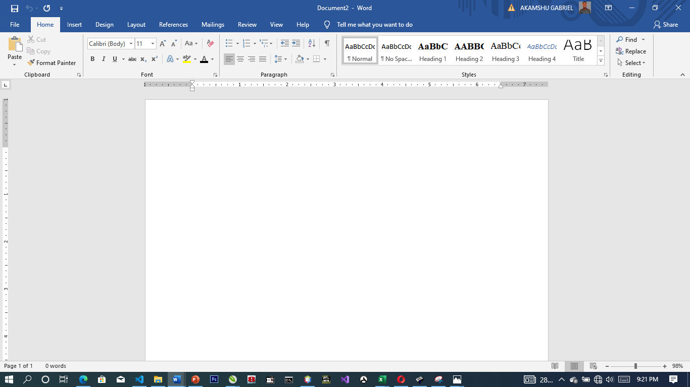

Figure 3.1: Microsoft Word Viewed Screen.

1. The title bar: wherever you saved any work, the file name and reside on the title bar
2. The menu bar: menu bar is made up of (file, edit, view, insert, format, tools, table, and window help).
3. The standard tool bar: consist of spelling and grammar icon, help.
4. The formatting tools bar: contain **(Bold (B), *(I), Italic* underline (U).**
5. **The drawing tools bar:** consist of any thin like auto shape, square, circle, text, word art pie chart, and bar chart etc.
6. **The insertion point:** or cursor is a place where you can insert table, row column etc.
7. **The ruler:** rule is mean for adjusting the MS-word environment etc.

**3.2 INTRODUCTION TO CORELDRAW**

**CORELDRAW:** is a software application package used mostly for graphic system designed. It is written by CorelDraw system cooperation and runs on Microsoft windows. It is known to be one of the best design graphic software. It uses mean to carry out most task operation need to created design and pattern.

**3.2.1 ADVANTAGES OF CORELDRAW.**

* + - 1. It is easy to create graphics and design.
      2. In the CorelDraw there is room for text entry and design.
      3. In CorelDraw these enhancement tool for measuring and object.
      4. It allowed us to manipulate graphics more than one.

**3.2.2 WAYS OF LOADING CORELDRAW.**

There are two basic ways which is mentioned below:

1. Click on start on the task bar (i.e. windows 7)
2. Click on all program.
3. Select CorelDraw. OR
4. Double click the icon on the desktop environment.

**3.2.3 DIFFERENT VERSION OF CORELDRAW.**

There are many tools in CorelDraw and here are few of them listed below.

1. Version 8
2. Version 9
3. Version 10
4. Version 11
5. Version 12
6. Version 13
7. Version 14
8. Version 17…e.t.c

**3.2.4 CORELDRAW TOOLS.**

There are many tools in CorelDraw and here are few of them listed below.

1. Pick tool
2. Shape tool
3. Eraser tool
4. Knife tool
5. Zoo tool
6. Hand tool
7. Free hand tool
8. Rectangle tool
9. Polygon tool
10. Eclipse tool
11. Artistic media

**3.2.5 HOW TO FIT TEXT TO PATH**

Fit text to path means making text to be in a circle or round from or any shape of your choice.

Below are steps of how to do it. Create the text and the shape style you want to use for your fit text path.

1. Highlight the destination path.
2. Select text
3. Go to text menu
4. Click on fit text to path command
5. Move your mouse pointer to hit destination path and click ok button.

**3.2.6 HOW POWERCLIP OBJECT**

An object created by placing object (contents objects) inside other (container objects).

**HOW TO CREATE A POWERCLIP OBJCT**

1. Click pick tool
2. Click the object
3. Click Effect on the menu bar
4. Click PowerClip.
5. Click place inside container

**3.3 MICROSOFT POWERPOINT**

**3.3.1 WHAT IS MICROSOFT POWERPOINT**

Microsoft PowerPoint is one of the most popular technology that is being used by many of us in our day in day out to present our views in more attractive and precise way with numerous special effects. With a few clicks, user can add graphics, text, visuals, sounds and many more effects. In most of the Business meetings, PowerPoint presentation making the sessions more interesting for the listeners compared to old traditional way of representation.  Sometimes abbreviated as PP or PPT, PowerPoint is a presentation [program](https://www.computerhope.com/jargon/p/program.htm) developed by [Microsoft](https://www.computerhope.com/comp/msoft.htm) that creates a slide show of important information, charts, and images for a presentation. It is most often used for business and school presentations.

## **3.3.2 POWEPOINT ribbon tabs**

The ribbon tabs group tools and features together based on their purpose. For example, to make your slides look better, look for options on the Design tab. The tools that you use to animate things on your slide would be on the Animations tab.

Here’s a look at what you’ll find in each of the PowerPoint ribbon tabs.

### 1. Home

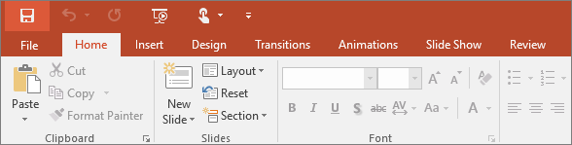

The Home tab holds the **Cut** and **Paste** features, **Font** and **Paragraph** options, and what you need to add and organize slides.

### 2. Insert

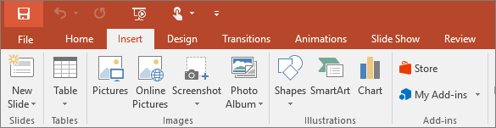

Click **Insert** to add something to a slide. This includes pictures, shapes, charts, links, text boxes, video and more.

### 3. Design

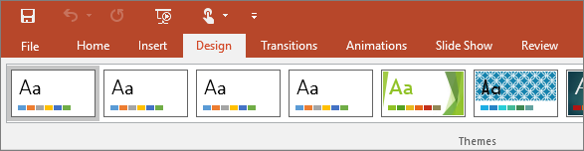

On the **Design** tab, you can add a theme or color scheme, or format the slide background.

### 4. Transitions

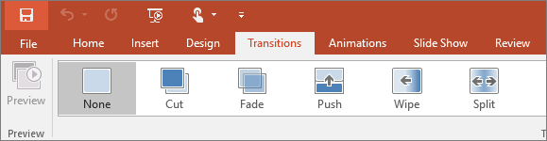

Set up how your slides change from one to the next on the **Transitions** tab. Find a gallery of the possible transitions in the **Transition to This Slide** group – click **More** More button at the side of the gallery to see all of them.

### 5. Animations

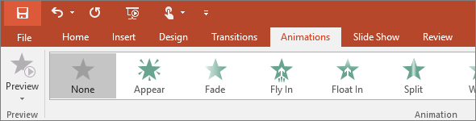

Use the **Animations** tab to choreograph the movement of things on your slides. Note that you can see many possible animations in the gallery in the Animation group, and see more of them by clicking **More** More button.

### 6. Slide Show

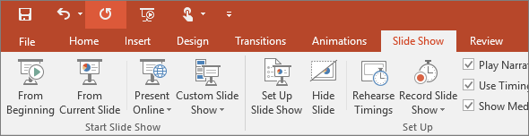

On the **Slide Show** tab, set up the way that you want to show your presentation to others.

### 7. Review

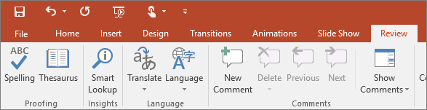

The **Review** tab lets you add comments, run spell-check, or compare one presentation with another (such as an earlier version).

### 8. View

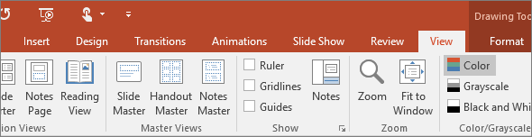

Views allow you to look at your presentation in different ways, depending on where you are in the creation or delivery process.

### 9. File

At one end of the ribbon is the **File** tab, which you use for the behind-the-scenes stuff you do with a file, such as opening, saving, sharing, exporting, printing and managing your presentation. Click the **File** tab to open a new view called the Backstage.

Click from the list on the side to do what you want to do; for example, click **Print** to find the options and settings for printing your presentation. Click Back Back to document to return to the presentation that you were working on.

### 10. Tools tabs

When you click some parts of your slides, such as pictures, shapes, SmartArt or text boxes, you might see a colorful new tab appear.

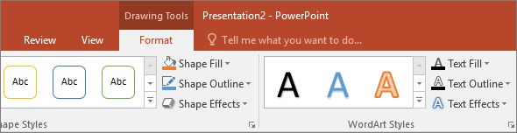

In the example above, the **Drawing Tools** tab appears when you click a shape or text box. When you click a picture, the **Picture Tools** tab appears. Other such tabs include SmartArt Tools, Chart Tools, Table Tools and Video Tools. These tabs disappear or change when you click something else in your presentation.

**HOW TO OPEN OR START POWERPOINT**

1. Click the Windows "Start" button, and then select “All Programs.”
2. Scroll through the list of folders that appear to find the folder labeled “Microsoft Office.”
3. Click that folder, and then click the “Microsoft PowerPoint” icon to open PowerPoint.

**How to start and stop a PowerPoint slide show**

After creating a set of slides or a presentation in [Microsoft PowerPoint](https://www.computerhope.com/jargon/p/powerpoi.htm), you can play the slides as a [slide show](https://www.computerhope.com/jargon/s/slidesho.htm), displaying them as [full screen](https://www.computerhope.com/jargon/f/fullscre.htm) on your computer. A PowerPoint slide show is an excellent visual aid when presenting important information and images to others on a web conference.

There are three ways to start a slide show in PowerPoint:

1. Open Microsoft PowerPoint, then open your presentation.
2. Click the Slide Show tab in the [Ribbon](https://www.computerhope.com/jargon/r/ribbon.htm).
3. To start the slide show from the first slide, click the From Beginning option in the Start Slide Show section.
4. To start the slide show from a slide other than the first, select that slide in your presentation, then click the From Current Slide option in the Start Slide Show section.

**Stop a PowerPoint slide show**

To stop a slide show that is currently running in PowerPoint, press the [Esc](https://www.computerhope.com/jargon/e/esc.htm) key. Upon doing so, the slide show ends and the PowerPoint program window is displayed again.

**3.4 INTRODUCTION TO MS ACCESS**

Microsoft Access is a Database Management System (DBMS) from Microsoft that combines the relational Microsoft Jet Database Engine with a graphical user interface and software development tools. It is a member of the Microsoft Office suite of applications, included in the professional and higher editions.

1. Microsoft Access is just one part of Microsoft’s overall data management product strategy.
2. It stores data in its own format based on the Access Jet Database Engine.
3. Like relational databases, Microsoft Access also allows you to link related information easily. For example, customer and order data. However, Access 2013 also complements other database products because it has several powerful connectivity features.
4. It can also import or link directly to data stored in other applications and databases.

**HOW TO USE MS ACCESS**

Microsoft Access stores information which is called a database. To use MS Access, you will need to follow these four steps:

1. **Database Creation** - Create your Microsoft Access database and specify what kind of data you will be storing.
2. **Data Input** - After your database is created, the data of every business day can be entered into the Access database.
3. **Query** - This is a fancy term to basically describe the process of retrieving information from the database.
4. **Report** (optional) - Information from the database is organized in a nice presentation that can be printed in an Access Report.

**Creating a Database**

1. Start **Access**
2. Click on **Blank desktop database**

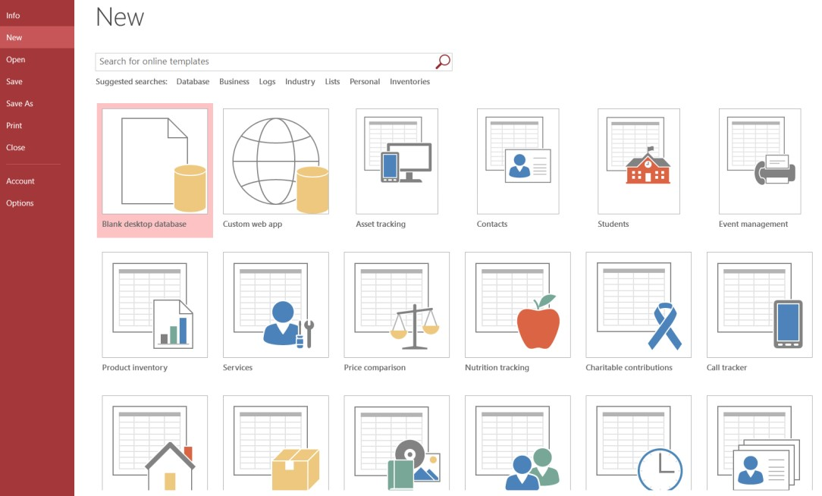

1. Under **File Name** type a name for the database
2. To change the location of where to store the database, click the folder icon and select a location
3. Click **Create**

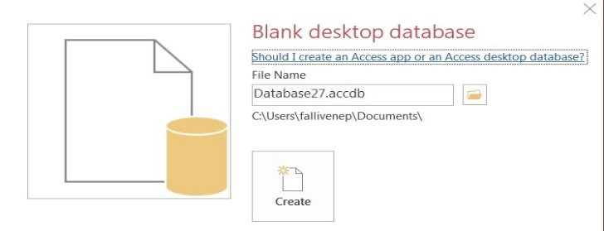

**To Save the Table:**

1. Click the **Save** icon on the toolbar
2. Enter a name for the table if you haven’t done so already
3. 3. Click **OK**

**Entering Data in a Table:**

1. In **Datasheet View**, start typing the data into the table by pressing the tab key to move to the next cell
2. When you have completed the record (row), press **Enter**
3. You can also click on the **New record** icon on the **Home** tab in the **Records** group

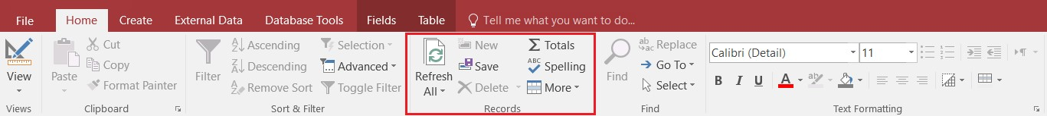

**Navigating in a Table:**

Use the arrows at the bottom of the table to navigate among records.



**Sorting Records in a Table:**

1. Position your cursor in the field that you wish to sort by clicking on any record in the table
2. Click either the **Sort Ascending** or **Sort Descending** icon on the **Home** tab in the **Sort & Filter** group

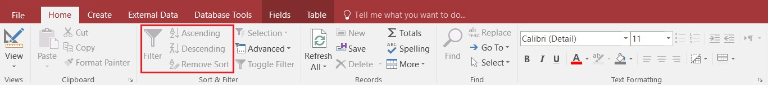

**Queries:**

You use queries to view, change, and analyze data in different ways. You can also use them as a source of records for forms and reports.

**To Create a Query:**

1. Click on the **Create** tab
2. Click on **Query Design** in the **Queries** group
3. Select the table that you would like to base your query on
4. Click **Add**
5. Repeat steps 3 and 4 until all tables are added
6. Close the Show Table window. The table(s) will now be displayed in the upper part of the **Query Design Screen** by boxes containing the tables’ fields.
7. **Double-click** on the field names in the field list window which you would like to include in the query

**Defining Criteria in the Query**

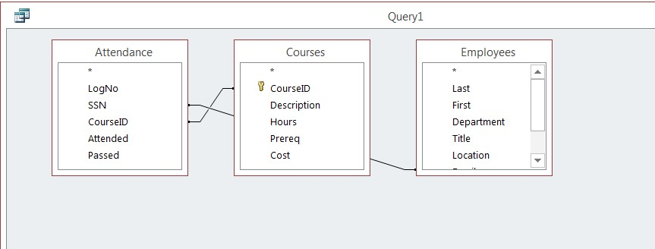

In order to control which records are displayed, you must define criteria in a query. The most common type of query is the **Select Records** query which will be discussed below.

**To Define Criteria for Your Query:**

1. Position your cursor in the criteria row in the field for which you wish to define the criteria for
2. **Type** the criteria. Example: To find all Excel courses:
3. Position your cursor in the criteria row of the **Course ID** field
4. **Type** Excel (Access adds the quote marks to the criteria automatically when you tab to the next column)

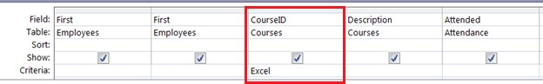

1. Click the **Run Query** button 

**To Save the Query:**

1. Click the **Save** icon
2. Enter a name for the query
3. Click **OK**

**MS ACCESS DATA TYPES**

|  |  |  |
| --- | --- | --- |
| **Type of Data** | **Description** | **Size** |
| **Short Text** | Text or combinations of text and numbers, including numbers that do not require calculating (e.g. phone numbers). | Up to 255 characters. |
| **Long Text** | Lengthy text or combinations of text and numbers. | Up to 63, 999 characters. |
| **Number** | Numeric data used in mathematical calculations. | 1, 2, 4, or 8 bytes (16 bytes if set to Replication ID). |
| **Date/Time** | Date and time values for the years 100 through 9999. | 8 bytes. |
| **Currency** | Currency values and numeric data used in mathematical calculations involving data with one to four decimal places. | 8 bytes. |
| **AutoNumber** | A unique sequential (incremented by 1) number or random number assigned by Microsoft Access whenever a new record is added to a table. | 4 bytes (16 bytes if set to Replication ID). |
| **Yes/No** | Yes and No values and fields that contain only one of two values (Yes/No, True/False, or On/Off). | 1 bit. |

**CREATE A TABLE IN DESIGN VIEW**

**To Create a Table in Design View:**

1. Click on the **Create** tab
2. Click on **Table**
3. Switch over to **Design View** on the **Home** tab
4. If prompted to save the table, enter a name and click on **OK**
5. Type the field names and select the appropriate data type for each field
6. Continue until all fields are added

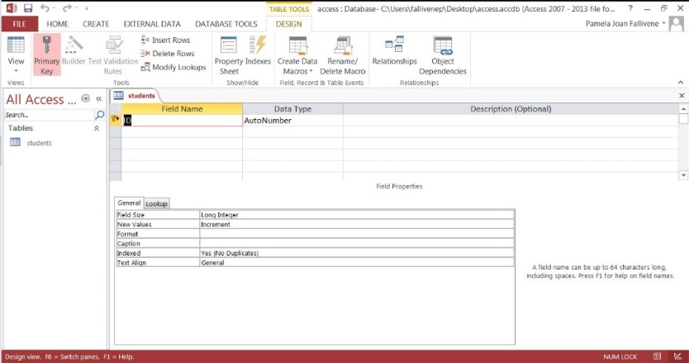

**3.5 INTRODUCTION to HTML**

**3.5.1 What is HTML?**

* HTML is the standard markup language for creating Web pages.
* HTML stands for Hyper Text Markup Language
* HTML describes the structure of Web pages using markup
* HTML elements are the building blocks of HTML pages
* HTML elements are represented by tags
* HTML tags label pieces of content such as "heading", "paragraph", "table", and so on.
* Browsers do not display the HTML tags, but use them to render the content of the page

**HTML Tags**

HTML tags are element names surrounded by angle brackets:

<tagname>content goes here...</tagname>

* HTML tags normally come in pairs like <p> and </p>
* The first tag in a pair is the start tag, the second tag is the end tag
* The end tag is written like the start tag, but with a forward slash inserted before the tag name

**WEB BROWSERS**

The purpose of a web browser (Chrome, IE, Firefox, Safari) is to read HTML documents and display them.

The browser does not display the HTML tags, but uses them to determine how to display the document:

**HTML VERSIONS**

Since the early days of the web, there have been many versions of HTML:

**Version Year**

HTML 1991

HTML 2.0 1995

HTML 3.2 1997

HTML 4.01 1999

XHTML 2000

HTML5 2014

**HTML EDITORS**

Web pages can be created and modified by using professional HTML editors.

1. Notepad (Windows) or TextEdit (Mac).
2. Sublime
3. Notepad ++
4. Atom, etc.

**HTML PARAGRAPHS**

HTML paragraphs are defined with the <p> tag:

Example

<p>This is a paragraph.</p>

<p>This is another paragraph.</p>

**HTML Headings**

Headings are important in HTML documents.

Headings are defined with the <h1> to <h6> tags.

<h1> defines the most important heading. <h6> defines the least important heading.

Example

<h1>This is heading 1</h1>

<h2>This is heading 2</h2>

<h3>This is heading 3</h3>

<h4>This is heading 4</h4>

<h5>This is heading 5</h5>

<h6>This is heading 6</h6>

**HTML Comments**

Comment tags are used to insert comments in the HTML source code.

You can add comments to your HTML source by using the following syntax:

<!-- Write your comments here -->

With comments you can place notifications and reminders in your HTML:

Example

<!-- This is a comment -->

<p>This is a paragraph.</p>

<!-- Remember to add more information here -->

»

**HTML Links**

Links are found in nearly all web pages. Links allow users to click their way from page to page.

**HTML Links - Hyperlinks**

HTML links are hyperlinks. You can click on a link and jump to another document.

When you move the mouse over a link, the mouse arrow will turn into a little hand.

**Note**: A link does not have to be text. It can be an image or any other HTML element.

**HTML Images**

JPG Images

GIF Images

PNG Images

Example

<!DOCTYPE html>

<html>

<body>

<h2>Spectacular Mountain</h2>

<img src="pic_mountain.jpg" alt="Mountain View" style="width:304px;height:228px; ">

</body>

</html>

»

**HTML Tables**

An HTML table is defined with the <table> tag.

Each table row is defined with the <tr> tag. A table header is defined with the <th> tag. By default, table headings are bold and centered. A table data/cell is defined with the <td> tag.

Example

<table style="width:100%">

<tr>

<th>Firstname</th>

<th>Lastname</th>

<th>Age</th>

</tr>

<tr>

<td>Jill</td>

<td>Smith</td>

<td>50</td>

</tr>

<tr>

<td>Eve</td>

<td>Jackson</td>

<td>94</td>

</tr>

</table>

**HTML Lists**

**Unordered HTML List**

An unordered list starts with the <ul> tag. Each list item starts with the <li> tag.

The list items will be marked with bullets (small black circles) by default:

Example

<ul>

<li>Coffee</li>

<li>Tea</li>

<li>Milk</li>

</ul>

**Ordered HTML List**

An ordered list starts with the <ol> tag. Each list item starts with the <li> tag.

The list items will be marked with numbers by default:

Example

<ol>

<li>Coffee</li>

<li>Tea</li>

<li>Milk</li>

</ol>

**Ordered HTML List - The Type Attribute**

The type attribute of the <ol> tag, defines the type of the list item marker:

**Type Description**

type="1" The list items will be numbered with numbers (default)

type="A" The list items will be numbered with uppercase letters

type="a" The list items will be numbered with lowercase letters

type="I" The list items will be numbered with uppercase roman numbers

type="i" The list items will be numbered with lowercase roman numbers

**3.6 What is CSS?**

**CSS** stands for **C**ascading **S**tyle **S**heets. CSS describes **how HTML elements are to be displayed on screen, paper, or in other media.** CSS **saves a lot of work**. It can control the layout of multiple web pages all at once. External stylesheets are stored in **CSS files**. CSS is a language that describes the style of an HTML document.

### CSS Example

body {  
    background-color: lightblue;}  
 h1 {  
    color: white;  
    text-align: center;}  
p {  
    font-family: verdana;  
    font-size: 20px;}

# Applying CSS

There are three ways to apply CSS to HTML: **Inline**, **internal**, and **external**.

## **Inline**

Inline styles are plonked straight into the HTML tags using the style attribute.

They look something like this:

<p style="color: red">text</p>

This will make that specific paragraph red.

But, if you remember, the best-practice approach is that the HTML should be a stand-alone, **presentation free** document, and so in-line styles should be avoided wherever possible.

## **Internal**

Embedded, or internal, styles are used for the whole page. Inside the [head](http://www.htmldog.com/references/html/tags/head/) element, the [style](http://www.htmldog.com/references/html/tags/style/) tags surround all of the styles for the page.

<!DOCTYPE html>

<html>

<head>

<title>CSS Example</title>

**<style>**

**p {**

**color: red;**

**}**

**a {**

**color: blue;**

**}**

**</style>**

This will make all of the paragraphs in the page red and all of the links blue.

Although preferable to soiling our HTML with inline presentation, it is similarly usually preferable to keep the HTML and the CSS files separate, and so we are left with our saviour.

## **External**

External styles are used for the whole, multiple-page website. There is a **separate CSS file**, which will simply look something like:

p {

color: red;

}

a {

color: blue;

}

If this file is saved as “style.css” in the same directory as your HTML page then it can be linked to in the HTML like this:

<!DOCTYPE html>

<html>

<head>

<title>CSS Example</title>

<link rel="stylesheet" href="style.css">

# CSS Syntax and Selectors

## **CSS Syntax**

A CSS rule-set consists of a selector and a declaration block:

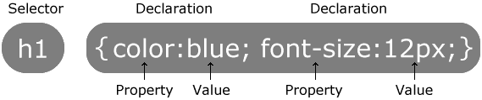

The selector points to the HTML element you want to style. The declaration block contains one or more declarations separated by semicolons. Each declaration includes a CSS property name and a value, separated by a colon.

A CSS declaration always ends with a semicolon, and declaration blocks are surrounded by curly braces.

## **Lengths and Percentages**

There are many property-specific units for values used in CSS, but there are some general units that are used by a number of properties and it is worth familiarizing yourself with these before continuing.

1. **px** (such as font-size: 12px) is the unit for pixels.
2. **em** (such as font-size: 2em) is the unit for the calculated size of a font. So “2em”, for example, is two times the current font size.
3. **pt** (such as font-size: 12pt) is the unit for points, for measurements typically in printed media.
4. **%** (such as width: 80%) is the unit for… wait for it… percentages.

Other units include picas, centimeters, millimeters and inches.

## **CSS Selectors**

CSS selectors are used to "find" (or select) HTML elements based on their element name, id, class, attribute, and more.

## **The Element Selector**

The element selector selects elements based on the element name. You can select all <p> elements on a page like this (in this case, all <p> elements will be center-aligned, with a red text color):

### Example

p {  
    text-align: center;  
    color: red;  
}

## **The id Selector**

The id selector uses the id attribute of an HTML element to select a specific element. The id of an element should be unique within a page, so the id selector is used to select one unique element! To select an element with a specific id, write a hash (#) character, followed by the id of the element.

The style rule below will be applied to the HTML element with id="para1":

### Example

#para1 {  
    text-align: center;  
    color: red;  
}

## **The Class Selector**

The class selector selects elements with a specific class attribute. To select elements with a specific class, write a period (.) character, followed by the name of the class.

In the example below, all HTML elements with class="center" will be red and center-aligned:

### Example

.center {  
    text-align: center;  
    color: red;  
}

## **CSS Comments**

Comments are used to explain the code, and may help when you edit the source code at a later date. A CSS comment starts with /* and ends with */. Comments can also span multiple lines:

### Example

p {  
    color: red;  
    /* This is a single-line comment */  
    text-align: center;  
}

**CHAPTER FOUR**

**SUMMARY, CONCLUSION, PROBLEMS AND RECOMMENDATION**

# 4.1 SUMMARY

The relevance of the SIWES program cannot be over emphasized considering the fact that it has significantly reduced the gap between my theoretical and practical knowledge about computer hardware and software, installations, maintenance and networking. The processes of communication which include data and telecommunication the use of switch in the networking and what networking is all about.

The program is indeed a commendable one in that it affords students ample opportunities of being exposed to good working relationship with colleagues and the field experience with customers. This little exposure has widened my knowledge about my course of study, not only that it has automatically changed my views about lift in general. The firm at large has taught me how to be independent of my own how to be conscious of my health and safety at its peak relating to the environment where I carried out my SIWES program. It was indeed a highly rewarding experience to be with Kponkius Dev Computer Institute, Mubi, Adamawa State.

**4.2 CONCLUSION**

In conclusion, I thank ITF in general for their effort towards the Student Industrial Training Scheme. The contribution that the industrial training offered to student will not be over emphasized. It has exposed me seriously to a certain depth and length of practical capability on Web Designs.

It has also acquainted me with the working condition, which I am expected to encounter in the near future. I will say that SIWES has a greater advantage on me, it has greatly exposed me to the practical application of all that I have been through in the school, SIWES is an experience that all student must pass through this is because it gives a full practical knowledge of what has been through in classroom.

Finally, I have a strong believe that this comprehensive based on the experience, I acquired during the industrial training scheme will convince every user training is not difficult.

I therefore strong conclude that the continuous existence of SIWES programme as it is very necessary since it plays a dominant role in the development of student of Computer Science in the acquisition of practical experience.

# 4.3 PROBLEMS OBSERVED DURING MY PROGRAM

1. The time frame set for the program is too short as some of the aspects of the program where not completed.
2. Lack of Financial support from the company to aid transportation to and from training.
3. Attentions are not given to the IT students by the workers it is learn if you want to learn or ask if you want to know.
4. Cost of Training: The Student has to be registered as a student of a particular organization in order to carry out the program.
5. Lack of Visits to the various places of Attachment by the ITF Officials to ensure that the student is actually carrying out the program.

**4.4 RECOMMENDATIONS**

Below are the recommendations that should be given serious consideration so as alleviate the suffering of students undergoing SIWES.

Firstly, the Federal Government of Nigerian should make a positive effort in reducing the overall cost of production so that companies should be producing to fill capacity and accommodate SIWES populaces. Also, certain monthly allowance may be given to the student by company accepted then (student to ease transportation problem).

Secondly, the Industrial Training Fund (ITF), should try and increase the money paid at the end of SIWES to the student so as to justify the Cost of Living we experienced.

Thirdly, the period set for the SIWES should be increase to six mouths so as to enable the student involved and gain enough experience since it is widely believed that experience is the best teacher. Again, this period should also be in line with Nigerian University Commission curriculum for the university undergraduate student on industrial attachment.

Finally, the ITF official should please continue visiting the students, to ensure that what they are learning is in line with the ITF requirement.

**REFERENCES**

Edward, B. M.D (2003). The Effect of SIWES on a student, Federal Ministry of Works, Lagos. Nigeria.

John, Doe (2008). Introduction to web development: responsive designs, McGraw Print New York.